The project involves developing a game called “Lutemon,” inspired by Pokémon. The game features five different types of creatures called “Lutemons” (white, green, pink, orange, and black) with distinct attributes. Users can create, train, and battle these Lutemons in an Android application built using Java in Android Studio.
Features:
Lutemon Management:
Create different types of Lutemons with unique stats.
Newly created Lutemons are placed in “Home.”
Users can move Lutemons to a training area or battle arena.
2. Training System:
Lutemons gain experience points when trained.
Experience increases attack power
3. Turn-Based Battle System:
Users select two Lutemons for battle.
Turn-based combat where one attacks, the other defends.
Battle continues until one Lutemon’s health reaches zero.
Winner gains an experience point; loser is removed.
4. Lutemon Recovery:
When a Lutemon returns home, its health is fully restored while experience points remain.
Our team: Veselin Georgiev (002292434), Toki Ahmed (002466231)
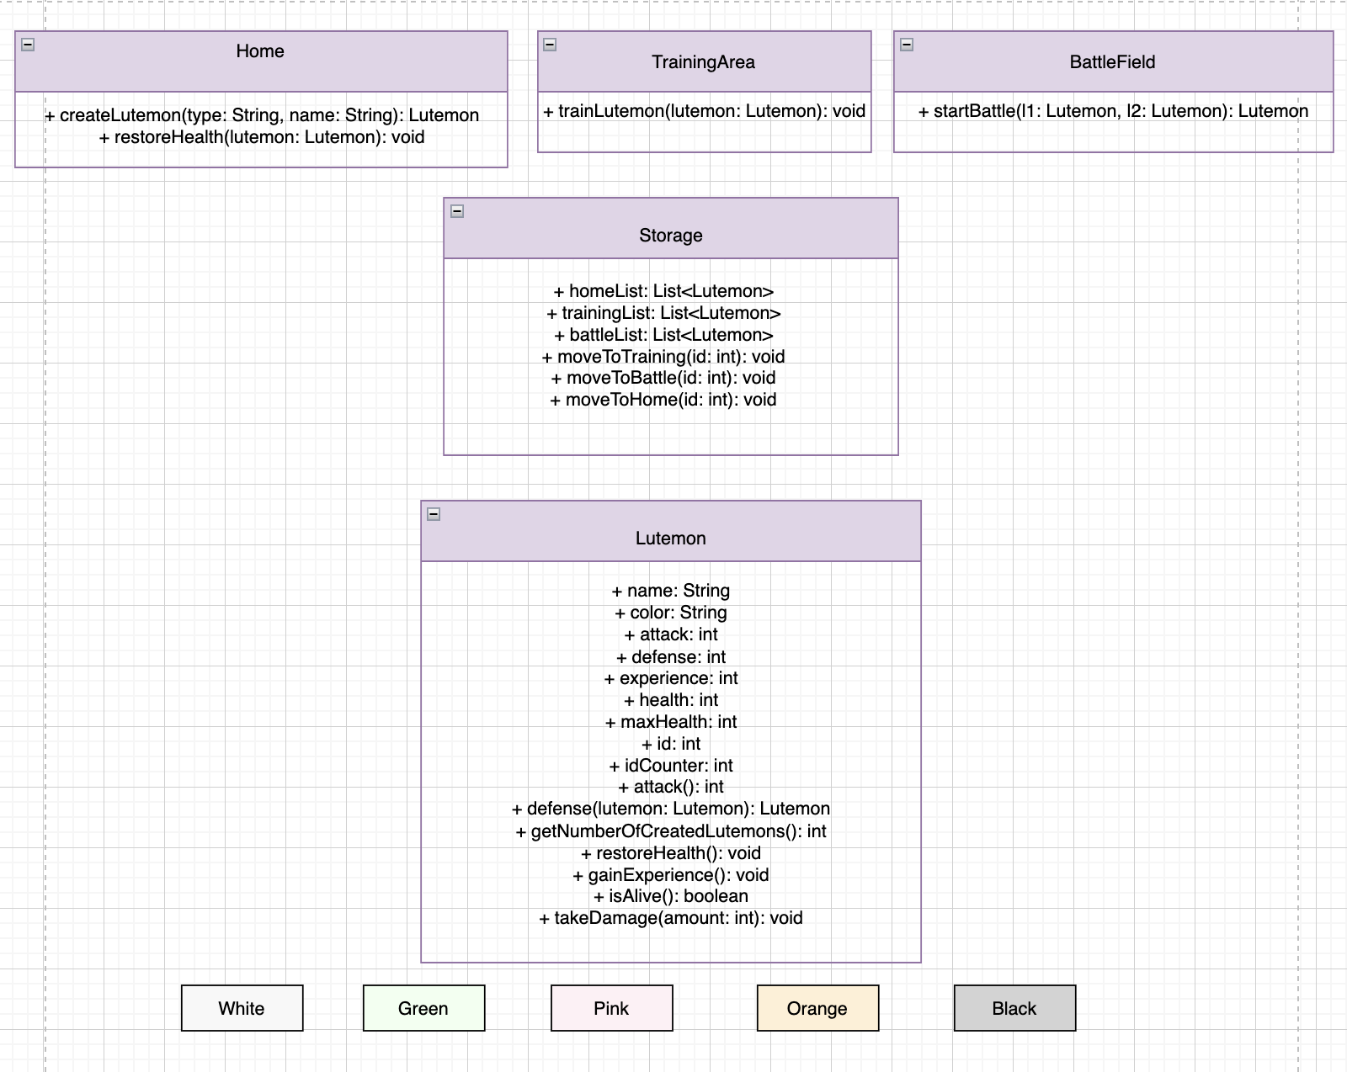

User interface description:
- Home Screen (Main Menu)
Displays game title and navigation buttons.
Options: “Create Lutemon,” “Train Lutemon,” “Battle,” and “View Lutemons.”
- Create Lutemon Screen
Users select a Lutemon type (White, Green, Pink, Orange, Black).
Enter a custom name for the Lutemon.
Created Lutemons are stored in the “Home” section.
- Lutemon Storage Screen
Displays all Lutemons categorized by their location (Home, Training Area, Battle Arena).
Users can select a Lutemon and move it between locations.
- Training Area Screen
Shows Lutemons available for training.
Users select a Lutemon and initiate training.
Training increases the Lutemon’s experience.
- Battle Screen
Users select two Lutemons to battle.
Displays health, attack, and defense stats.
Turn-based combat system where one attacks and the other defends.
Displays battle logs and determines the winner.
- Lutemon Details Screen
Shows detailed stats of a selected Lutemon (health, attack, defense, experience).
Options to move the Lutemon, restore health (if in Home), or delete it.

